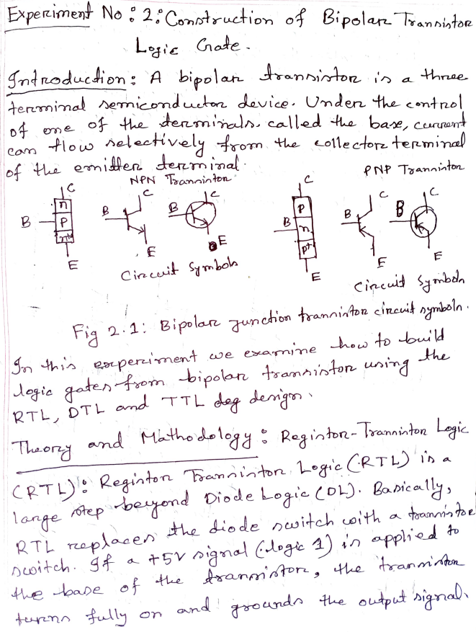

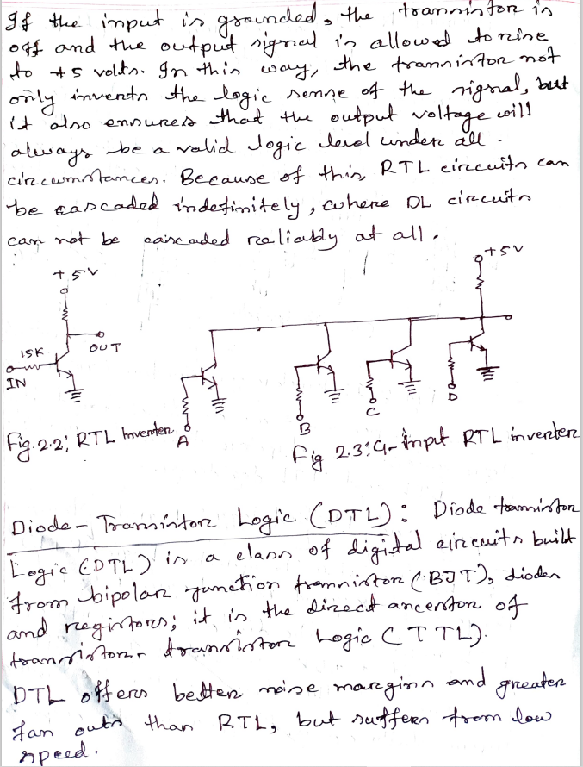

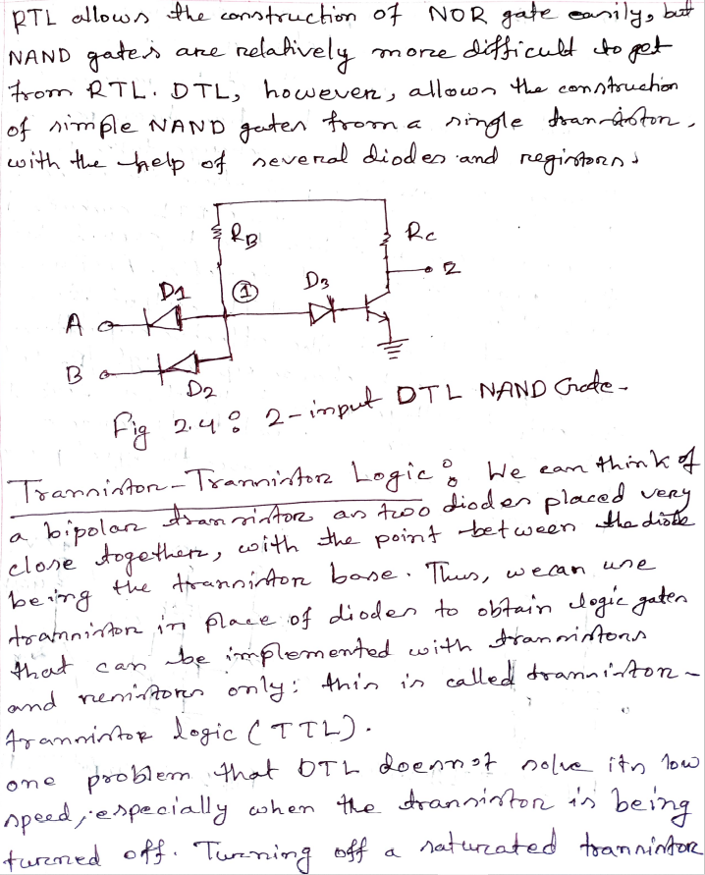

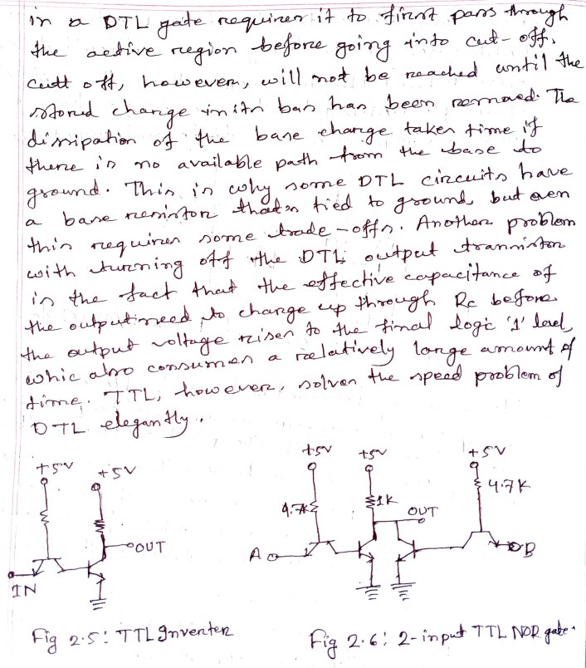

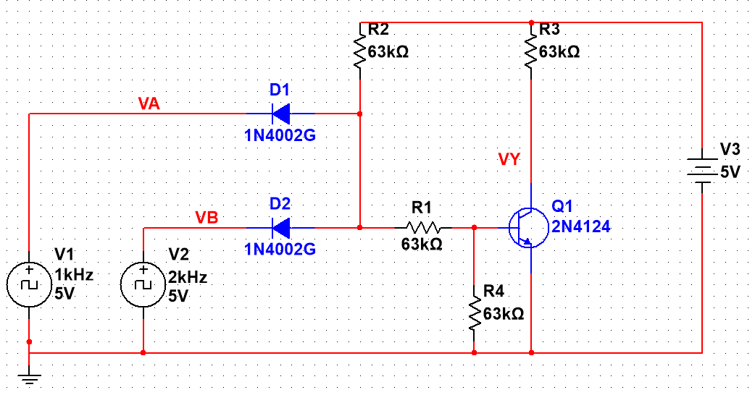**Block Diagrams:**

Fig 1: 2 Input DTL NAND Block Diagram.

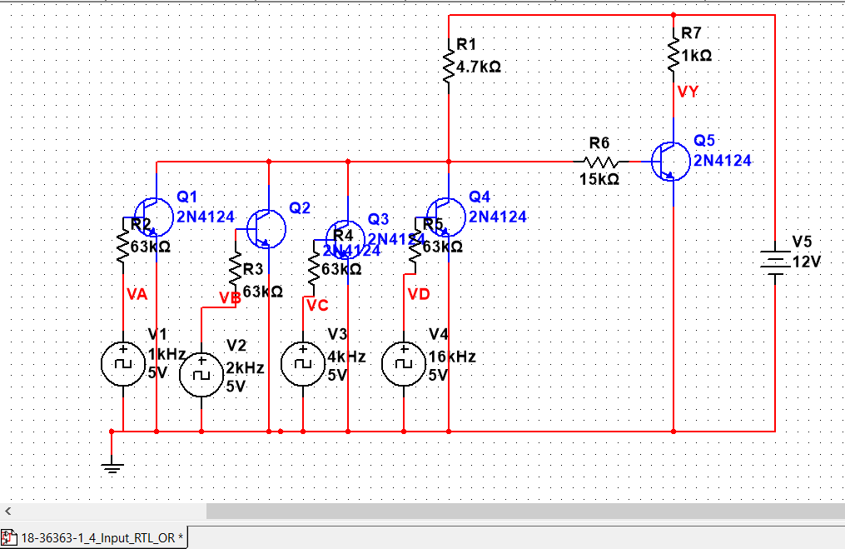

Fig 2: 4 Input RTL OR Block Diagram.

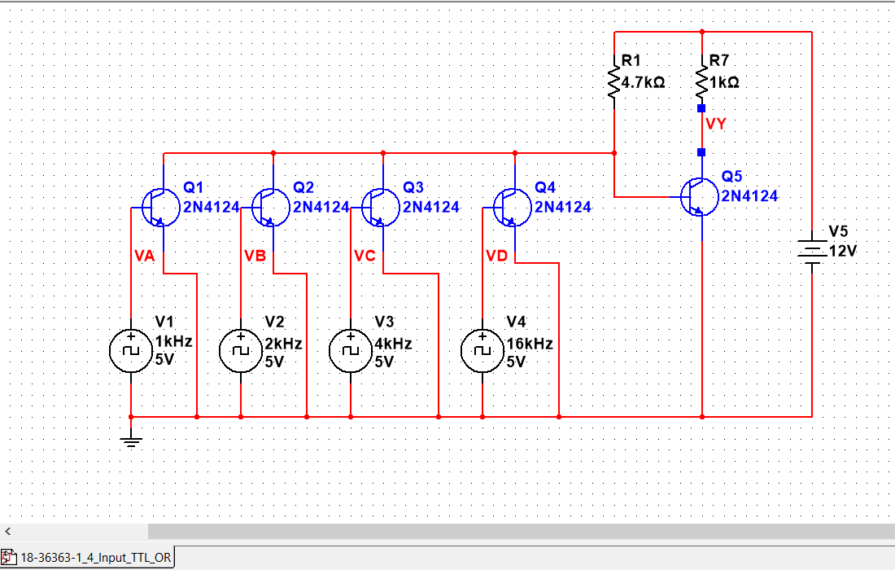

Fig 3: 4 Input TTL OR Block Diagram.

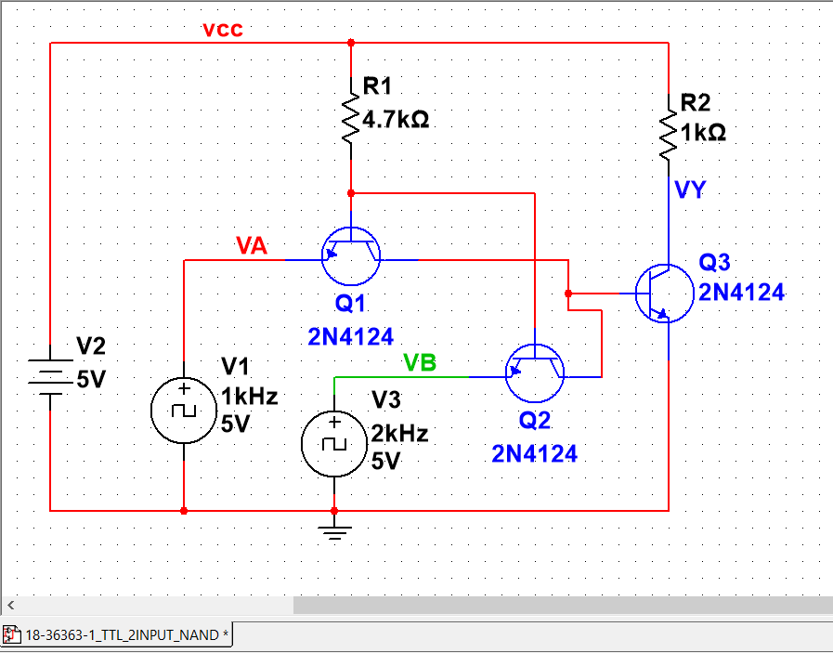

Fig 4: 2 Input TTL NAND Block Diagram.

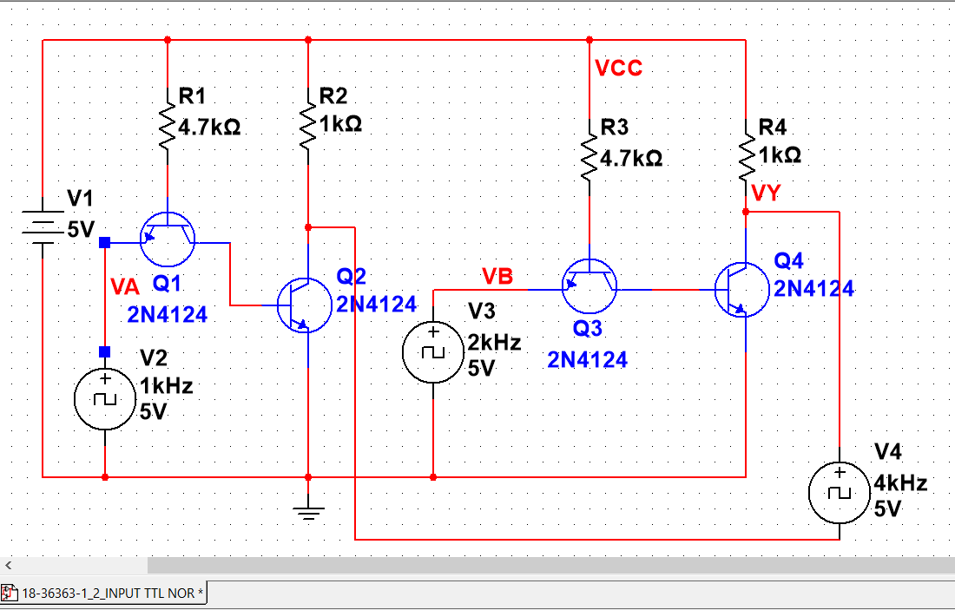

Fig 5: 2 Input TTL NOR Block Diagram.

**Graphs:**

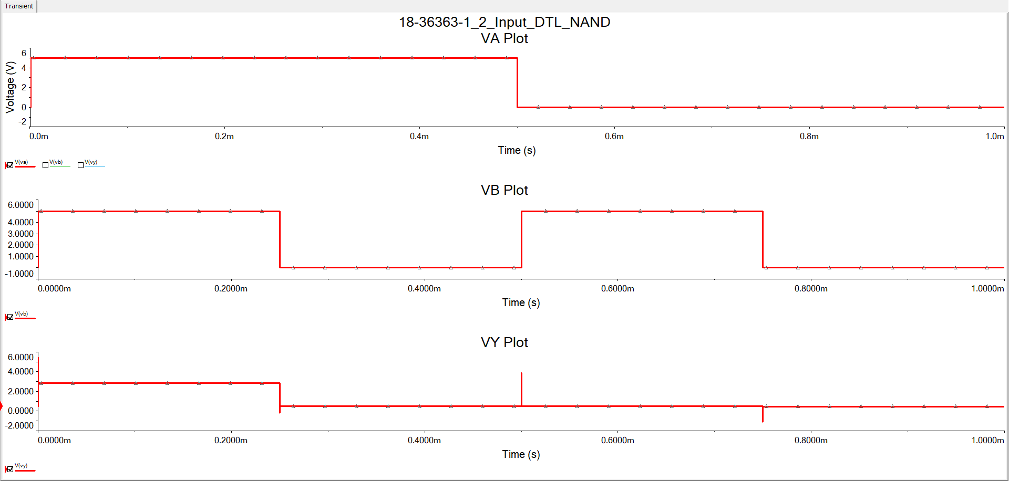

Fig 6: 2 Input DTL NAND Graph.

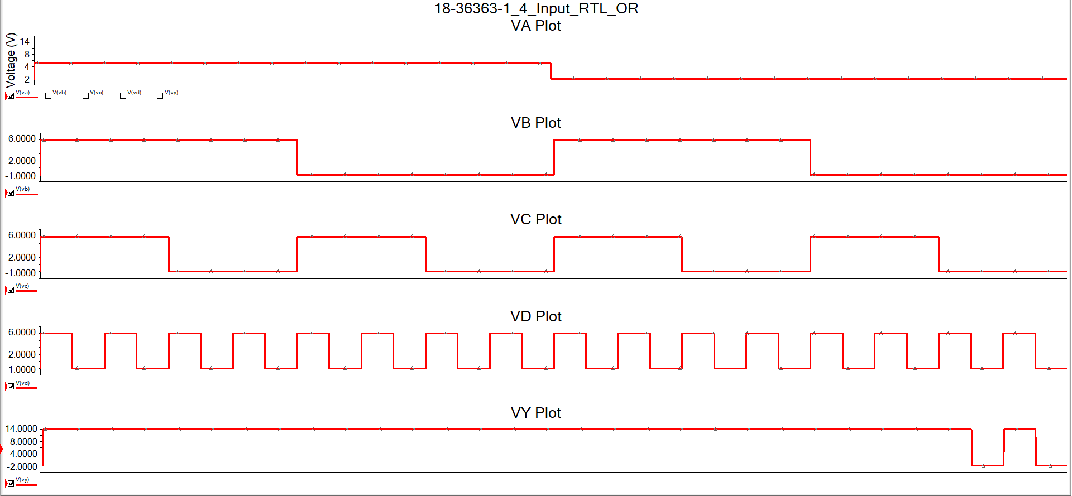

Fig 7: 4 Input RTL OR Graph.

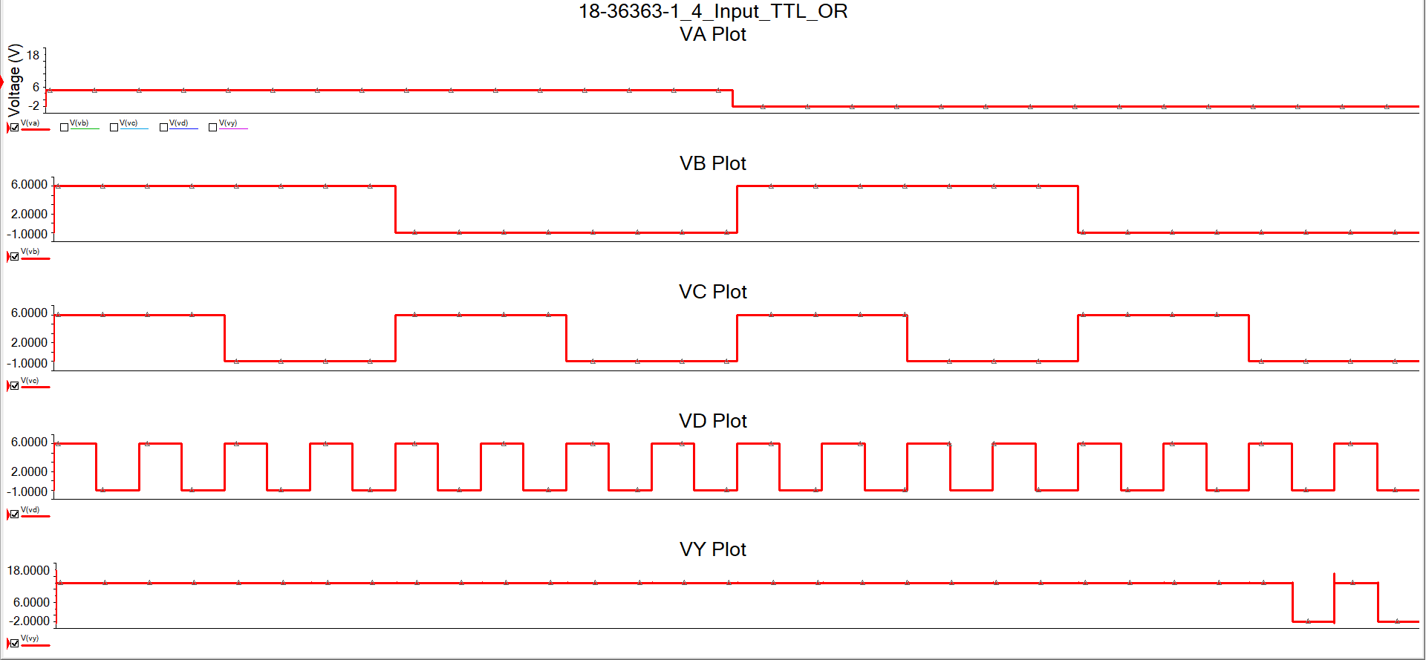

Fig 8: 4 Input TTL OR Graph.

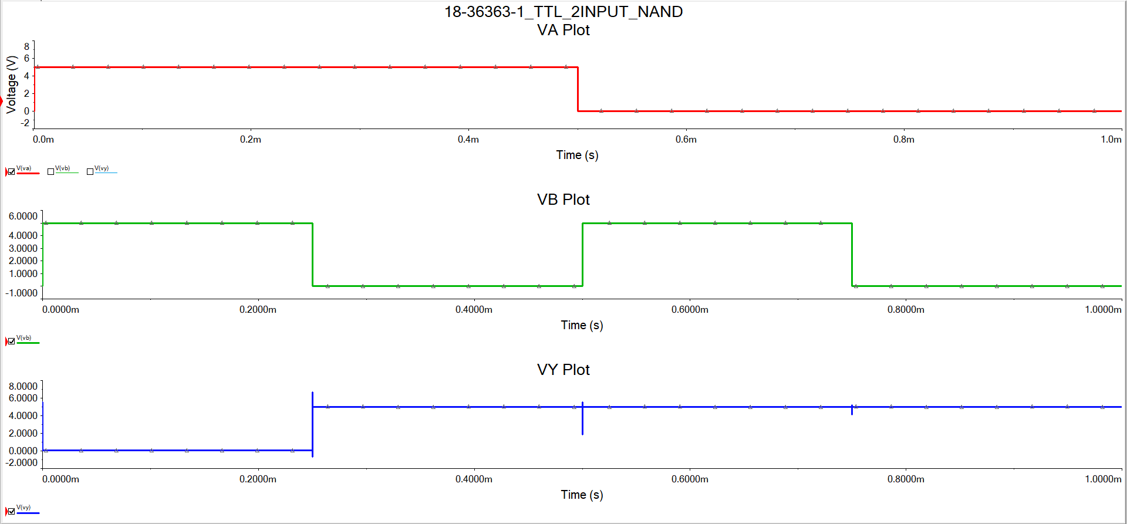

Fig 9: 2 Input TTL NAND Graph.

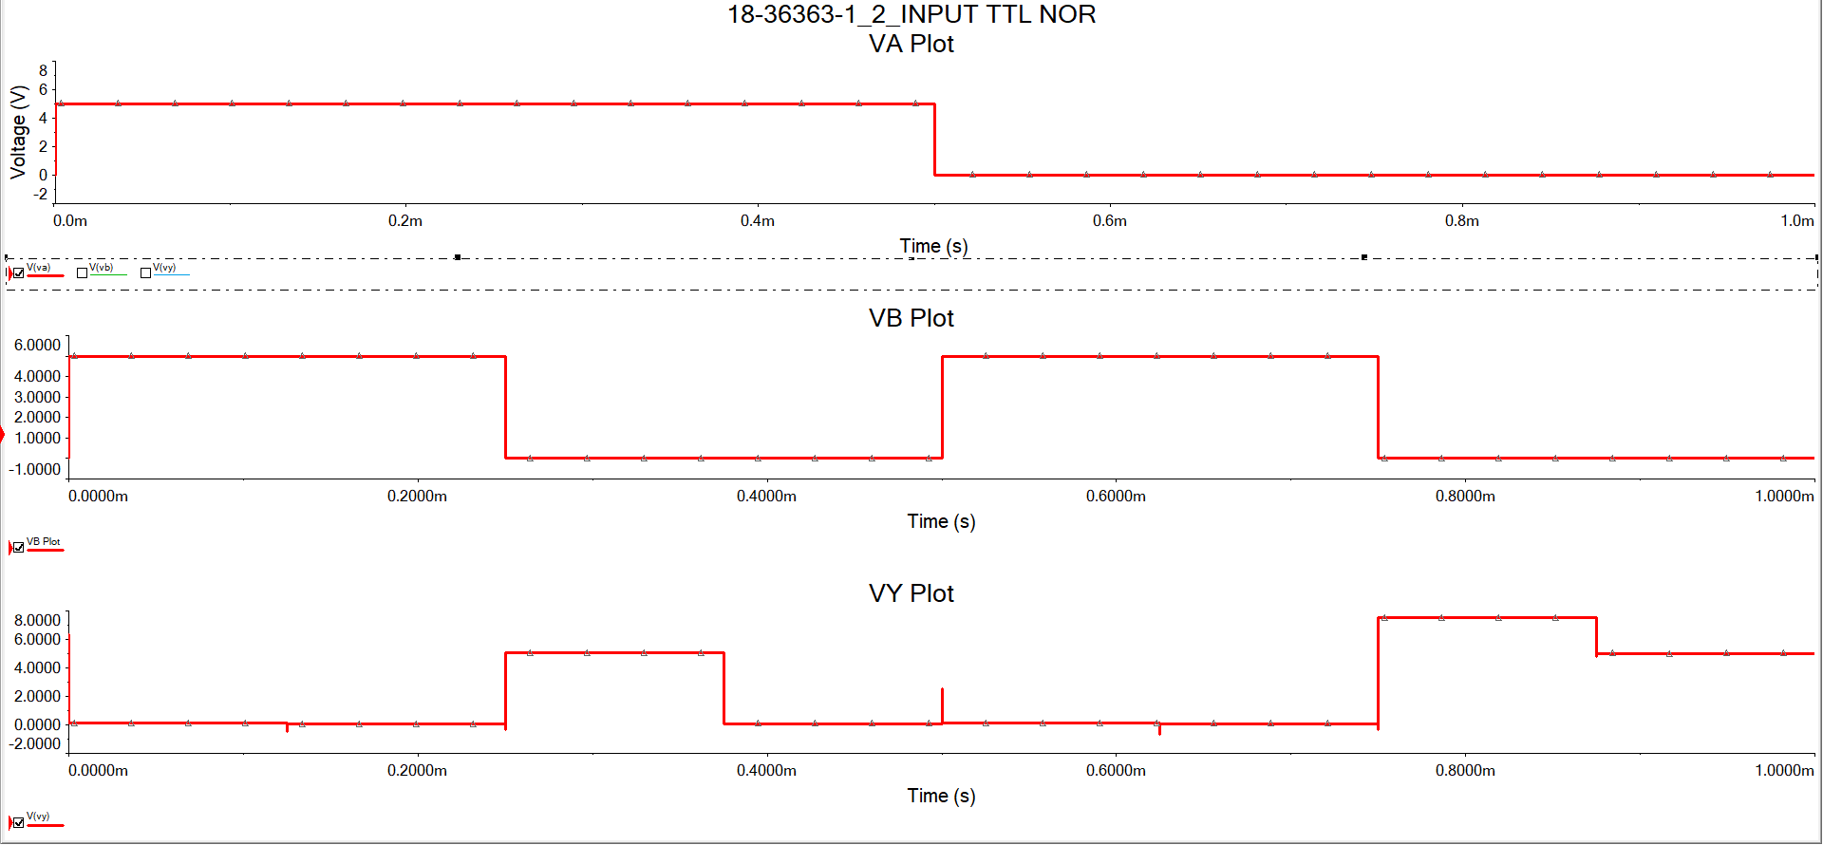

Fig 10: 2 Input TTL NOR Graph.

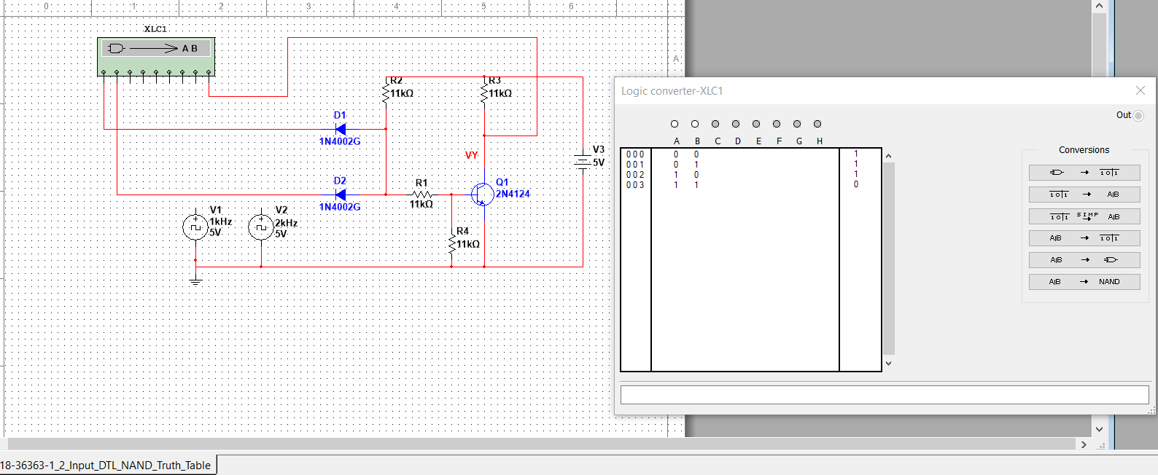**Truth Tables:**

Fig 11: 2 Input DTL NAND Truth Table.

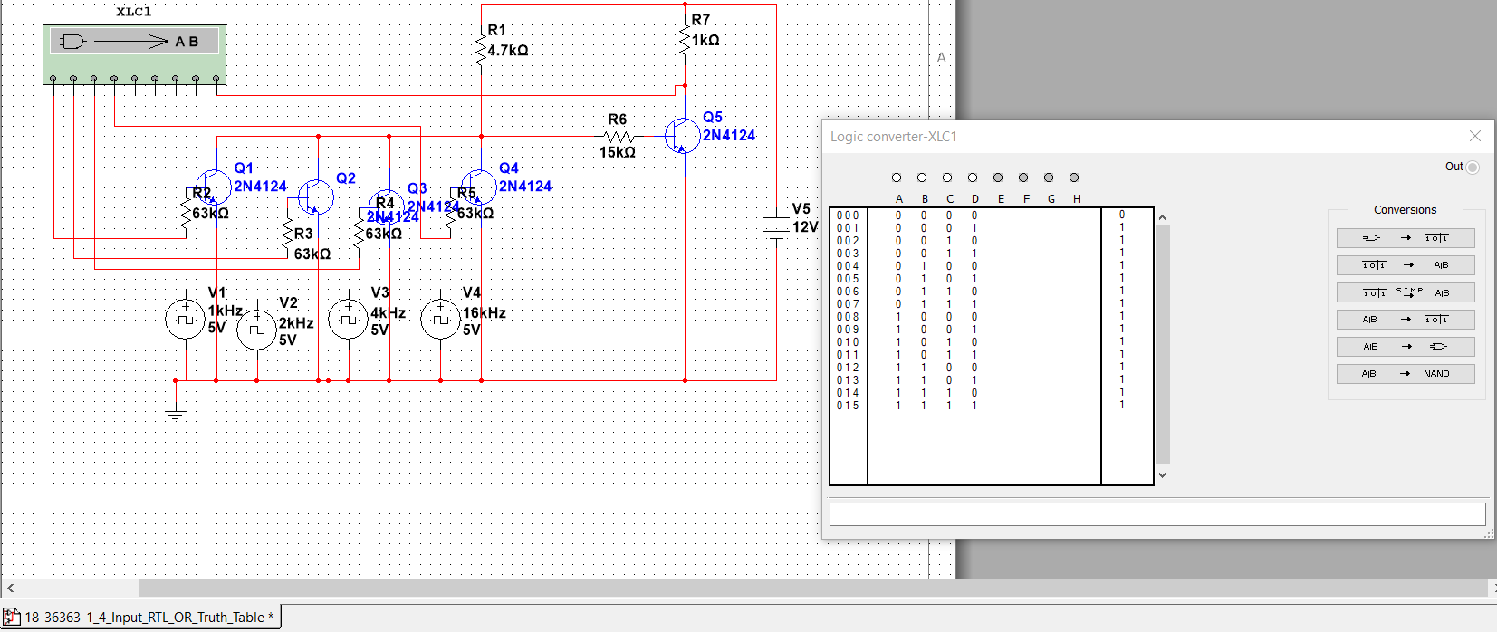

Fig 12: 2 Input RTL OR Truth Table.

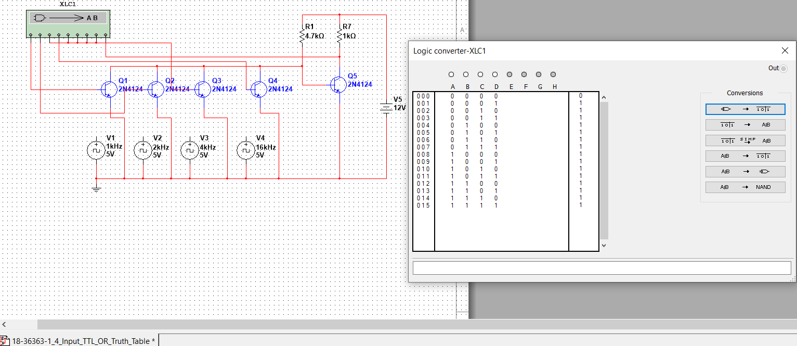

Fig 13: 4 Input TTL OR Truth Table.

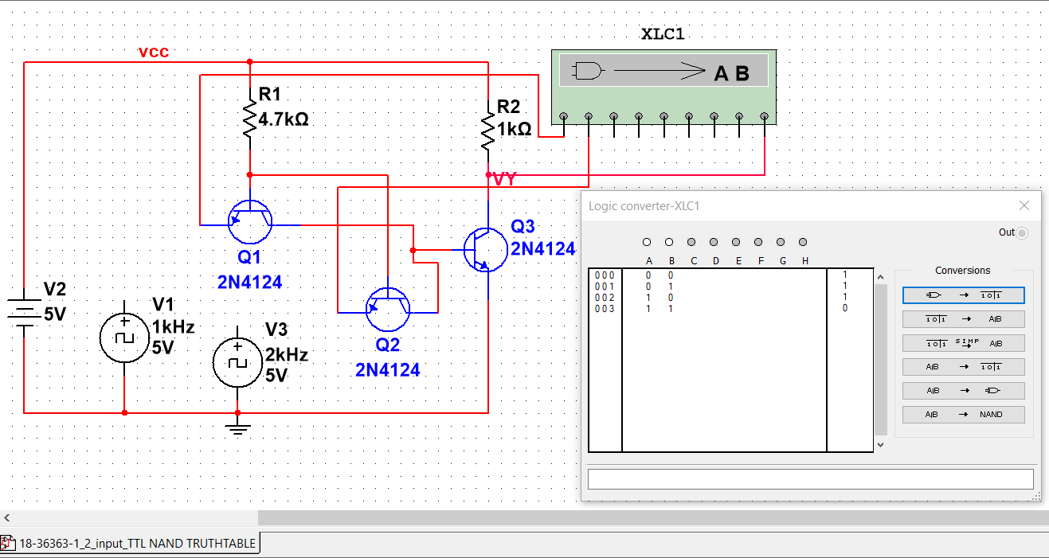

Fig 14: 2 Input TTL NAND Truth Table.

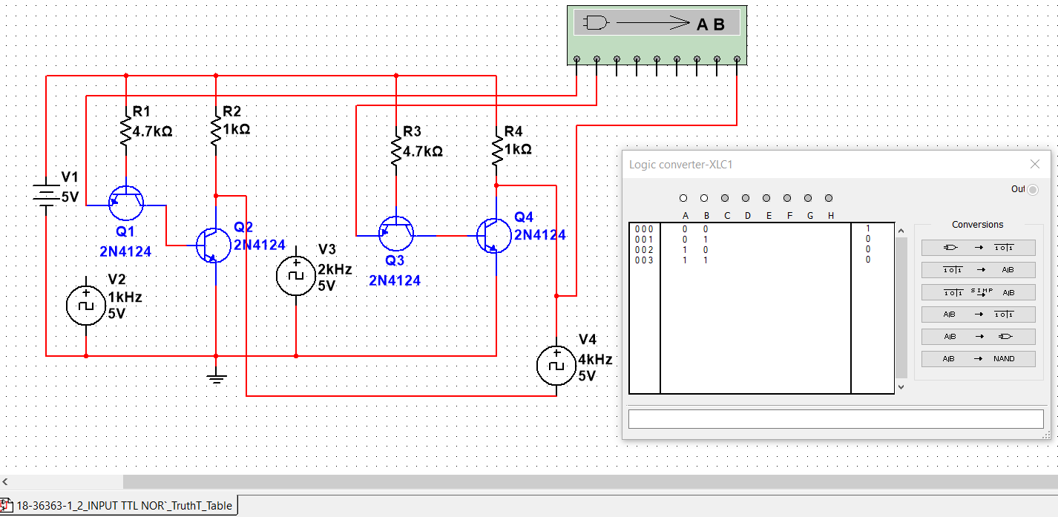

Fig 15: 2 Input TTL NOR Truth Table.